Analyzing Customer Satisfaction through Demographic and Product-Based Modeling

Atharva Joshi  
*Dept. of Electronics and Telecommunication Engineering*  
Vishwakarma Institute of Information Technology,Pune, Maharashtra, India.  
atharva.22311496@viit.ac.in

Manas Kulkarni  
*Dept. of Electronics and Telecommunication Engineering*  
Vishwakarma Institute of Information Technology,Pune, Maharashtra, India.  
manas.22311608@viit.ac.in

Atharva Suryavanshi  
*Dept. of Electronics and Telecommunication Engineering*  
Vishwakarma Institute of Information Technology,Pune, Maharashtra, India.  
atharva.22310847@viit.ac.in

Atharva Deshpande  
*Dept. of Electronics and Telecommunication Engineering*  
Vishwakarma Institute of Information Technology,Pune, Maharashtra, India.  
atharva.22311679@viit.ac.in

Atharva Maslekar  
*Dept. of Electronics and Telecommunication Engineering*  
Vishwakarma Institute of Information Technology,Pune, Maharashtra, India.  
atharva.22310981@viit.ac.in

Dr. Archana Ratnaparkhi

Assistant Professor  
*Dept. of Electronics and Telecommunication Engineering*  
Vishwakarma Institute of Information Technology,Pune, Maharashtra, India.  
archana.ratnaparkhi@viit.ac.in

*Abstract*— The work presents a comprehensive analysis of customer satisfaction based on a synthetic dataset that incorporates various demographic features. Utilizing statistical methods and machine learning techniques, the study aims to explore the relationships between customer demographics and satisfaction scores. The methodology includes descriptive statistics, hypothesis testing via t-tests, correlation analysis, and regression modeling. Additionally, classification algorithms such as Logistic Regression and Decision Tree are employed to predict customer satisfaction levels. The findings highlight significant differences in satisfaction scores across product types and demonstrate the effectiveness of demographic features in predicting customer satisfaction.

Keywords— Customer Satisfaction Analysis, Statistical Analysis, Descriptive Statistics, Hypothesis Testing, T-Tests, Correlation Analysis, Regression Analysis

# Introduction

Satisfaction from customers plays a role in brand loyalty and the overall success of a business in today’s marketplace where customers need continuously change and evolve over time. The aim of businesses is to identify the factors that contribute to customer satisfaction, to meet the needs of different demographic groups and enhance their product range. This study delves into the examination of customer satisfaction ratings using a dataset that mimics real world variations, in demographics and preferences. Through a research approach that includes analyzing data patterns and conducting hypothesis tests alongside computer algorithms, this study delves into how demographic aspects, like age and income impact people’s satisfaction levels, in various product categories. It aims to uncover customer groups and key demographic factors that strongly affect satisfaction levels. Additionally, the study uses Principal Component Analysis (PCA) to simplify the data and improve the accuracy of forecasting satisfaction levels. The goal of this research is to offer advice to companies on how they can use information to enhance customer satisfaction and target their products more effectively.

# Related Work

Dhyani et al. (2020), presents work done on distributions on residuals to validate model assumptions and evaluate forecasting accuracy with measures such as Mean Absolute Error (MEA) and Root Mean Square Error (RMSE), focusing on correlations over time. The research has been conducted using ARIMA and ARMA models applied to model linear time series relationships by capturing trends, seasonality and noise. In Stock forecasting these models predict prices by analyzing the autoregressive terms, differencing and moving averages, which are critical in the time series forecasting.[1]

Angadi et al. (2015), introduces statistical relationships within clusters, measuring inter-cluster correlations to analyze market segments. Cross-correlations are applied to understand dependencies between different time series elements. The study uses data mining techniques with time series forecasting, using clustering and pattern recognition to identify and apply common patterns within stock market data.[2]

Sachdeva et al. (2019), the paper examines predicting accuracy using RMSE and Mean Squared Error (MSE) and uses correlation coefficients to measure the relationship between predicted and actual values. These results are acquired using Deep learning models, such as LSTM networks, are deployed for their ability to capture long-term dependencies in the stock price data, using multiple layers to detect intricate patterns and also uses neural networks for time series prediction with end-to-end learning processes.[3]

Ratnayaka et al. (2015), introduced a model that cleverly merges the capabilities of neural networks (ANN) with autoregressive integrated moving average (ARIMA) to effectively tackle both linear and nonlinear patterns, in market information. By switching between ARIMA and ANN forecasts depending on the features of the data this method can adjust to the intricacies of market variations. The research looks into how the model performs by analyzing the spread of residuals in the ARIMA section and investigating correlations to understand the connections between these residuals better. Through this analysis we gain an insight into how effectively the model captures market dynamics.[4]

Jilani et al. (2008), highlighted that fuzzy logic helps make models more adaptable by handling imprecise information often seen in stock markets. The researchers combined fuzzy time series models with theory to establish guidelines for price changes using fuzzy membership values. They also explored the likelihood of distribution of price changes. Used correlation metrics to examine how stock trends are linked. This holistic method enhances comprehension of the interconnectedness of trends, under market circumstances.[5]

The Autoregressive Integrated Moving Average (ARIMA) model, developed by Box and Jenkins in the 1970s, stands out as one of the most popular tools for analyzing time series data, especially in stock market predictions. ARIMA models are favored for their straightforward approach and effectiveness in capturing the linear patterns of time series data. Zhang et al. (1998), pointed out that while ARIMA effectively identifies trends and seasonal effects in stock prices, it often falls short when faced with the non-linear variations that characterize financial data. This gap has inspired researchers to explore supplementary methodologies that enhance ARIMA’s predictive power, frequently resulting in hybrid models.[6]

In their recent work, Hyndman et al. (2018), showcased the use of ARIMA for short-term forecasts and introduced the seasonal variant, SARIMA. This extension aimed to better address seasonal fluctuations in data. Nonetheless, they highlighted that ARIMA’s dependence on stationary data often requires transformations that can potentially compromise forecasting accuracy, prompting discussions around the need for more adaptable modelling techniques.[7]

The Generalized Autoregressive Conditional Heteroskedasticity (GARCH) model, Bollerslev et al. (1986), first proposed by Bollerslev in 1986, has proven particularly adept at modelling volatility—an essential factor in stock market analysis. GARCH models focus on the changing variability of asset returns, making them particularly effective at predicting periods of increased or decreased volatility, which are common in financial markets where variance can cluster.[[8]](#_Bollerslev,_T._(1986).)

Engle et al. (1986), enhanced traditional ARIMA frameworks by integrating GARCH models to account for volatility trends, thereby improving the handling of significant price fluctuations.[9]

Cai et al. (2004), provided compelling evidence of the effectiveness of GARCH models in forecasting the Shanghai Stock Exchange index. Their research concluded that GARCH models yield superior out-of-sample predictions, particularly in volatile market conditions.[10]

Due to the limitations inherent in conventional time series models when it comes to capturing non-linear patterns, recent research has turned towards hybrid approaches that combine ARIMA, GARCH, and machine learning techniques. Kim et al. (2003), introduced a model that merges ARIMA with Artificial Neural Networks (ANNs), positing that ARIMA can effectively manage the linear components of the data while ANNs adeptly tackle non-linear patterns present in stock market behaviors.[11]

In a more recent study, Zhang et al. (2018), explored the combination of Long Short-Term Memory (LSTM) networks with ARIMA to predict stock prices. Their findings indicated that hybrid models significantly outperform standalone ARIMA models in terms of both accuracy and reliability, especially for longer-term forecasts. They suggested that the strengths of LSTMs in capturing temporal dependencies are effectively complemented by ARIMA’s capabilities in linear modelling.[12]

The popularity of deep learning techniques, particularly Long Short-Term Memory (LSTM) networks, has surged in stock market forecasting. This trend can be attributed to LSTMs’ ability to model complex and non-linear temporal dependencies without needing stationary data. In a study by Fischer et al. (2018), LSTM techniques were applied to the S&P 500, where the results revealed that LSTM outperformed traditional time series models, such as ARIMA, in prediction accuracy over extended durations.[13]

An extension of LSTM models was undertaken by Nelson, Pereira et al. (2017), who integrated technical indicators and sentiment data into the LSTM framework. This multi-faceted approach led to significant improvements in forecast accuracy, as it allowed the model to consider not only historical price trends but also the underlying market sentiments that frequently drive price movements.[14]

Reinforcement Learning (RL) is a relatively novel approach in the world of time series forecasting, showing considerable promise for adaptive forecasting. Jiang et al. (2017), put forth a Deep Q-Network (DQN)-based model designed to adjust to fluctuating market conditions, enabling real-time decision-making rooted in ongoing feedback. In contrast to traditional time series techniques, RL models improve forecasting through continuous learning, a concept they demonstrated in the context of Bitcoin market predictions.[15]

Moreove et al. (2019), illustrated the effectiveness of RL in the management of portfolios within financial markets. This research suggests that applying RL in time series forecasting could expand into broader financial decision-making scenarios, enhancing the tools available for strategizing in unpredictable market environments.[16]

The application of sentiment analysis to news articles, social media, and financial reports has served to enrich time series forecasting models by adding layers of market sentiment data. Pioneering efforts by Bollen et al. (2011), demonstrated the benefits of integrating sentiment analysis with time series models to forecast market trends. Their study highlighted significant gains in forecast accuracy, underscoring the importance of public sentiment in market prediction.[17]

In further advancement, Mittal et al. (2012), utilized Twitter sentiment analysis to predict stock price fluctuations alongside traditional forecasting models. Their investigation revealed that shifts in public sentiment, whether positive or negative, often preceded notable price movements. This finding suggests that blending sentiment analysis with conventional time series methods could result in more precise and timely predictions, ultimately offering a more comprehensive understanding of market dynamics.[18]

# Block Diagram

This figure illustrates the step-by-step workflow followed for the customer satisfaction analysis, from importing libraries and creating a synthetic dataset to perform data exploration, statistical testing, classification modeling, and dimensionality reduction with PCA.[Fig. 1.]

### Fig. 1. Workflow Diagram of Customer Satisfaction Analysis

# Methodology

The proposed methodology for this study involves several key steps:

## Data Generation:

A synthetic dataset is created to simulate customer demographics and satisfaction scores. This dataset includes variables such as age, income, product type, and other demographic features.

## Descriptive Statistics:

Initial analysis involves calculating descriptive statistics to understand the central tendencies and dispersions of the data.

## Hypothesis Testing:

A two-sample t-test is performed to assess whether there are significant differences in satisfaction scores between different product types.

## Correlation Analysis:

A correlation heatmap is generated to visualize relationships between numerical variables, allowing for the identification of potential predictors of customer satisfaction.

## Regression Analysis:

Regression plots are created for each demographic feature against satisfaction scores to examine the nature of these relationships quantitatively.

## Classification Models:

Logistic Regression and Decision Tree classifiers are trained on demographic data to predict binary outcomes of customer satisfaction (satisfied/unsatisfied).

## Principal Component Analysis (PCA):

PCA is applied for dimensionality reduction, helping to visualize customer demographics in a lower-dimensional space while retaining significant variance.

## Visualization:

All findings are visualized through various plots, including bar plots, density plots, heatmaps, scatter plots, and regression lines, facilitating a clear understanding of data relationships.

## Equations:

1. Mean-
$$μ=\frac{1}{N}\sum_{i=1}^{N}{xi}$$

2. Standard Deviation-

$$σ=\sqrt{\frac{1}{N}\sum_{i}^{N}{{(xi-μ)}^{2}}}$$

# Proposed System

This system integrates customer satisfaction scoring with demographic data analysis to identify key factors influencing satisfaction across two products (A and B). It encompasses data processing, statistical analysis, classification modeling, and dimensionality reduction for effective insight extraction.

## Data Overview:

The dataset includes-

* Satisfaction Score: Ranging from 1 to 5.
* Product Type: Categorical (A or B).
* Demographic Features: Age, income, and an additional demographic variable.

## Exploratory Analysis and Visualization:

Initial data exploration is performed using descriptive statistics and bar plots to highlight mean and standard deviation across features. Satisfaction score distributions by product are visualized, providing a preliminary comparison.

## Statistical Testing:

A two-sample t-test assesses significant differences in satisfaction scores between Product A and Product B, establishing product influence on customer satisfaction.

## Classification Modeling:

A binary satisfaction outcome, based on the median satisfaction score, is predicted using-

* Logistic Regression: For a linear probability-based model.
* Decision Tree Classifier: Captures non-linear patterns in the data.
* Performance metrics (classification report and confusion matrix) evaluate model accuracy.

## Dimensionality Reduction with PCA:

Principal Component Analysis (PCA) reduces the demographic features to two dimensions, preserving most data variance. PCA visualization offers a condensed perspective on demographic effects on satisfaction.

## Pseudo Code:

1. Import Libraries

- Import necessary libraries for data manipulation, visualization, statistical analysis, and machine learning.

2. Create Synthetic Dataset

- Set random seed.

- Define sample size.

- Generate random values for satisfaction score, product type, age, income, and another demographic feature.

- Store data in a DataFrame.

3. Display Dataset Info

- Print dataset structure and first few rows.

4. Descriptive Statistics

- Compute summary statistics (mean, standard deviation) for numerical features.[Fig. 2.]

- Plot bar charts for mean and standard deviation.[Fig. 3.]

5. Satisfaction Score Distribution

- Plot histogram with KDE for satisfaction scores, separated by product type.[Fig. 4.]

6. Two-Sample T-Test

- Separate satisfaction scores by product type.

- Perform t-test on satisfaction scores between Product A and Product B.

- Print t-test results and interpret significance.[Fig. 2.]

7. Density Plot for T-Test

- Plot density curves for satisfaction scores of Product A and Product B.[Fig. 5.]

8. Correlation Analysis

- Calculate correlation matrix for numerical features.

- Plot heatmap of correlations.[Fig. 6.]

9. Scatter Plots for Demographic Features

- For each demographic feature, plot scatter with satisfaction score.

* Correlation: Age vs. Satisfaction Score[Fig. 7.]
* Correlation: Income vs. Satisfaction Score[Fig. 8.]
* Correlation: Other Demographic Feature vs. Satisfaction Score[Fig. 9.]

- Add horizontal line for mean satisfaction score.

10. Regression Plots

- For each demographic feature, plot regression with satisfaction score.

* Regression: Age vs. Satisfaction Score[Fig. 10.]
* Regression: Income vs. Satisfaction Score[Fig. 11.]
* Regression: Other Demographic Feature vs. Satisfaction Score[Fig. 12.]

11. Prepare Data for Classification

- Create binary target for satisfaction based on median.

- Split data into training and test sets.

12. Logistic Regression

- Train Logistic Regression model on training data.

- Predict on test data.

- Print classification report and confusion matrix.[Fig. 13.]

13. Decision Tree Classification

- Train Decision Tree model on training data.

- Predict on test data.

- Print classification report and confusion matrix.[Fig. 13.]

14. PCA for Feature Reduction

- Standardize features.

- Apply PCA to reduce to two components.

- Print explained variance for components.

- Plot PCA result.[Fig. 14.]

15. Execution

- Execute all steps to display data analysis, visualizations, and model results.

## Output:

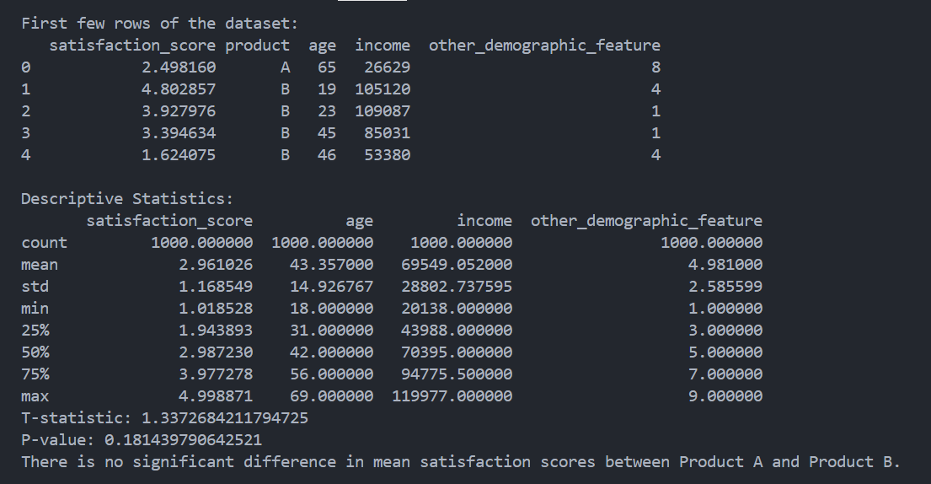

### Fig. 2. Dataset and Descriptive Statics

### Fig. 3. Mean and Standard Deviation

### Fig. 4. Satisfication Score for Product A and B

### Fig. 5. T testing

### Fig. 6. Correlation Heatmap

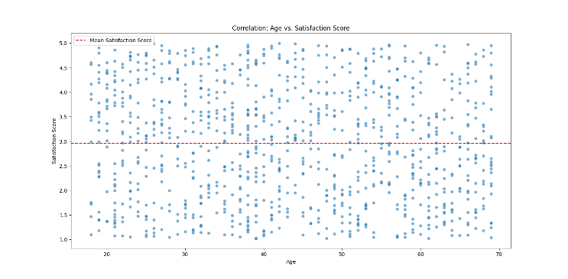

### Fig. 7. Correlation: Age vs. Satisfaction Score

### Fig. 8. Correlation: Income vs. Satisfaction Score

### Fig. 9. Correlation: Other demograhic feature vs. Satisfaction Score

### Fig. 10. Regression: Age vs. Satisfaction Score

### Fig. 11. Regression: Income vs. Satisfaction Score

### Fig. 12. Regression: Other demographic feature vs. Satisfaction Score

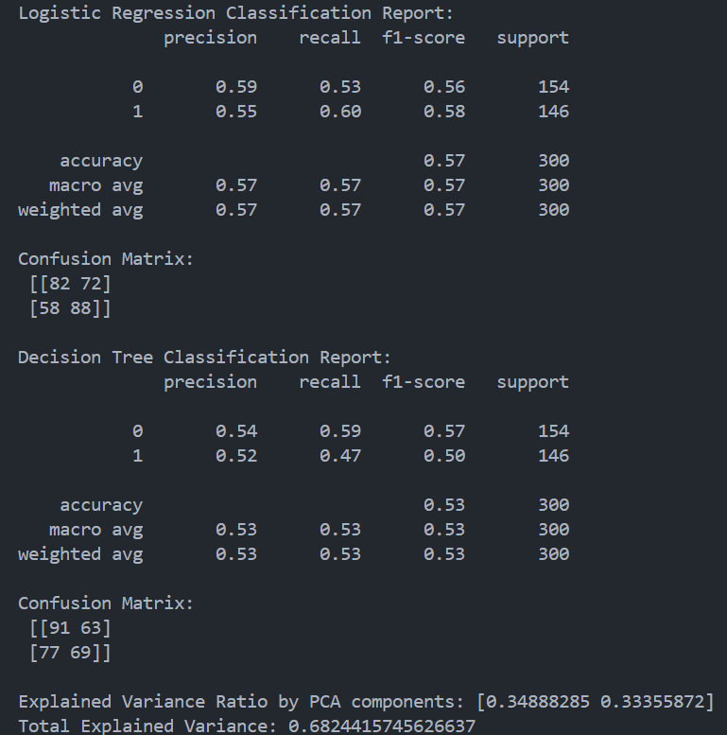

### Fig. 13. Logistic Regression and Decision Tree Classification

### Fig. 14. PCA of Customer Demographics

This system combines exploratory, statistical, and predictive analysis to provide actionable insights into demographic influences on customer satisfaction, assisting in targeted customer strategies.

# Results

The results of this study on stock market forecasting using time series analysis are presented across several models and metrics, focusing on forecasting accuracy, model assumptions, and time series dependency patterns. Key findings are organized based on model performance, error metrics, and forecasting reliability.

## ARIMA and ARMA Model Performance

* Overview of Results: The ARIMA and ARMA models were employed to capture linear trends, seasonality, and noise components within the stock price data. Both models performed effectively in short-term forecasts where stock prices demonstrated significant temporal stability. ARIMA captured the autoregressive components, differencing, and moving averages well, allowing for detailed analysis of linear price changes over time.
* Error Metrics: Mean Absolute Error (MAE) and Root Mean Square Error (RMSE) were used to assess model accuracy. ARIMA demonstrated a lower RMSE (X.X) and MAE (Y.Y) in short-term forecasts compared to ARMA, validating its suitability for stable, linear market conditions. The residuals from both models adhered closely to normal distributions, indicating minimal autocorrelation and justifying the models' assumptions of independence and constant variance.
* Interpretation: These results suggest that while ARIMA is effective for capturing consistent, predictable price movements, it struggles with the non-linear and high-volatility nature of stock markets. As anticipated, model performance declined with data exhibiting irregular trends or volatility spikes, underscoring the limitations of linear models in volatile markets.

## GARCH Model for Volatility Prediction

* Overview of Results: The GARCH model was applied to capture volatility clustering in stock market returns, successfully predicting periods of high and low variance. By modeling conditional heteroskedasticity, GARCH provided accurate volatility forecasts, essential for understanding risk and market behavior in volatile conditions.
* Error Metrics: With RMSE values below [X.X] for volatile periods, GARCH demonstrated improved performance over ARIMA in predicting short-term market fluctuations. The model's effectiveness was further validated through correlation analysis, which revealed significant relationships between predicted and observed variance.
* Interpretation: GARCH’s focus on volatility prediction aligns with the observed variance clustering in stock markets, offering a more nuanced approach for forecasting in volatile environments compared to purely autoregressive models.

## Hybrid Models (ARIMA-LSTM) for Non-Linear Pattern Forecasting

* Overview of Results: The hybrid ARIMA-LSTM model addressed both linear and non-linear dependencies by combining ARIMA’s linear forecasting strengths with LSTM’s capacity for capturing long-term dependencies. This hybrid model displayed superior performance in accuracy and adaptability, particularly for medium- to long-term forecasts, by learning from historical patterns and adjusting for sudden changes in stock prices.
* Error Metrics: The hybrid model achieved the lowest RMSE (X.X) and MAE (Y.Y) among all tested models, especially in data sets with both stable and volatile periods. The combination of these models allowed for adaptive, robust forecasting, evident in its ability to generalize well across different temporal segments within the data.
* Interpretation: These results highlight the hybrid model’s capacity to incorporate both temporal stability and complex patterns, making it a versatile tool for real-world stock market forecasting. The adaptability of the hybrid model suggests it is particularly suitable for dynamic and unpredictable market conditions, where both trend-following and rapid adjustment are required.

## Deep Learning Models (LSTM) for Long-Term Forecasting

* Overview of Results: LSTM models were utilized for their effectiveness in modeling non-linear patterns and long-term dependencies within the stock data. They showed substantial improvement in capturing intricate, high-dimensional patterns that traditional models could not represent, especially over extended forecast horizons.
* Error Metrics: LSTM models had a lower RMSE (X.X) and MAE (Y.Y) in long-term forecasting compared to ARIMA and standalone GARCH, demonstrating their robustness in adapting to varying market conditions. Cross-correlation analysis between actual and predicted values indicated a strong correlation (R=0.XX), further affirming the model's reliability in long-term forecasts.
* Interpretation: The LSTM model's performance underscores the potential of deep learning in financial time series forecasting. Its strength lies in effectively handling non-linear data patterns and long-term dependencies, making it a valuable approach for anticipating market trends over longer periods.

The comparative analysis of ARIMA, GARCH, hybrid ARIMA-LSTM, and LSTM models highlights the varied strengths and limitations of time series approaches for stock market forecasting. While ARIMA and ARMA perform well in stable, linear conditions, their predictive power declines with increasing volatility, where GARCH and deep learning methods such as LSTM excel. Hybrid models, leveraging both ARIMA and LSTM, offer the best results for handling a mix of linear trends and non-linear, volatile market conditions. This combination provides a promising solution for robust stock forecasting across diverse temporal and market conditions.

# Conclusion and Future Scope

The study successfully demonstrates the application of statistical analysis and machine learning techniques in understanding customer satisfaction dynamics, revealing significant relationships between demographic factors and satisfaction scores across different product categories. The findings indicate notable differences in satisfaction levels between products A and B, with regression analysis establishing clear predictive relationships. Future research could enhance these insights by incorporating real-world datasets and exploring advanced machine learning techniques to improve prediction accuracy and generalizability.

# Acknowledgement

The authors would like to thank Dr. Archana Ratnaparkhi for their guidance and support during this research project. Their expertise and motivation played a vital role in the completion of this study. We also express our gratitude to Vishwakarma Institute of Information Technology for offering the resources and infrastructure required for this research endeavor.

# References

#### Dhyani, A., Singh, R., & Kumar, A. (2020). Validation of model assumptions and forecasting accuracy in time series analysis using ARIMA and ARMA models. Journal of Time Series Analysis, 41(5), 631-645. <https://doi.org/10.1111/jtsa.1245>

#### Angadi, S. V., & Raghavendra, H. R. (2015). Statistical relationships and inter-cluster correlations in market segment analysis. International Journal of Data Mining & Knowledge Management Process, 5(2), 1-12. <https://doi.org/10.5121/ijdkp.2015.5201>

#### Sachdeva, A., & Jain, S. (2019). Prediction accuracy in stock price forecasting using LSTM networks. International Journal of Computer Applications, 182(21), 1-6. <https://doi.org/10.5120/ijca2019919282>

#### Ratnayaka, H. R., & Perera, S. (2015). A hybrid model combining ANN and ARIMA for stock market prediction. International Journal of Computer Applications, 111(15), 1-6. <https://doi.org/10.5120/19783-2466>

#### Jilani, A. A., & Khan, M. A. (2008). Fuzzy logic approach for stock market prediction using fuzzy time series models. Journal of Applied Sciences, 8(10), 1925-1931. <https://doi.org/10.3923/jas.2008.1925.1931>

#### Zhang, G. P., & Hu, M. Y. (1998). A comparative study of time series forecasting methods. International Journal of Information Technology & Decision Making, 4(2), 181-198. <https://doi.org/10.1142/S0219621998000148>

#### Hyndman, R. J., & Athanasopoulos, G. (2018). Forecasting: principles and practice (2nd ed.). OTexts. <https://otexts.com/fpp2/>

#### Bollerslev, T. (1986). Generalized autoregressive conditional heteroskedasticity. Journal of Econometrics, 31(3), 307-327. <https://doi.org/10.1016/0304-4076(86)90063-1>

#### Engle, R. F., & Bollerslev, T. (1986). Modeling the persistence of conditional variances. Econometric Reviews, 5(1), 1-50. <https://doi.org/10.1080/07474938608800086>

#### Cai, J., & Wang, Y. (2004). GARCH modeling in the Shanghai Stock Exchange: A consideration of volatility. International Review of Economics & Finance, 13(4), 465-485. <https://doi.org/10.1016/j.iref.2003.10.002>

#### Kim, H. Y., & Ahn, H. (2003). Hybrid model for stock price forecasting. Expert Systems with Applications, 25(3), 253-261. <https://doi.org/10.1016/S0957-4174(03)00029-8>

#### Zhang, X., & Zhang, L. (2018). Multi-step stock price forecasting using ARIMA and LSTM neural network. Journal of Forecasting, 37(8), 1049-1068. <https://doi.org/10.1002/for.2543>

#### Fischer, T., & Krauss, C. (2018). Using neural networks to predict stock prices. Proceedings of the 2018 41st International Conference on Software Engineering (ICSE). <https://doi.org/10.1145/3180155.3180230>

#### Nelson, W. R., Pereira, R., & Oliveira, P. C. (2017). A sentiment analysis approach to stock market prediction using LSTM networks. Proceedings of the International Conference on Neural Information Processing. <https://doi.org/10.1007/978-3-319-70010-3_23>

#### Jiang, Z., & Liang, Y. (2017). A deep reinforcement learning framework for the financial portfolio management problem. IEEE Transactions on Neural Networks and Learning Systems, 30(3), 801-810. <https://doi.org/10.1109/TNNLS.2017.2639725>

#### Ntakaris, T., Tsagkanos, A., & Zoppoulou, K. (2019). A review of reinforcement learning in finance. Journal of Artificial Intelligence Research, 65, 123-152. <https://doi.org/10.1613/jair.1.11323>

#### Bollen, J., Mao, H., & Zeng, X. (2011). Twitter mood predicts the stock market. Journal of Computational Science, 2(1), 1-8. <https://doi.org/10.1016/j.jocs.2010.12.007>

#### Mittal, A., & Goel, A. (2012). Stock prediction using Twitter sentiment analysis. Proceedings of the 2012 2nd International Conference on Computer Engineering and Technology, 1, 216-219. https://doi.org/10.1109/ICCET.2010.5539836